Chapter 4

SYSTEM ANALYSIS
________________________________________________

  - STUDY OF CURRENT SYSTEM

The current system for the Student Management System deals with maintaining a physical contact with the academy management dept. for filling all the details and the documentation work. The management doesn’t needs to visit the academy management dept. and collect the assignment and submitting his/her documents directly.
According to the current system, the management has to fill in the forms manually, go to the account management dept., and submit him the form. The applicant needs to visit the academy portal now and then in order to get his work accomplished. The admin also has to manage all the users. He needs to maintain records of all the users, their activity status, submission methods and installation details on paper. The Manual process is more error prone and also slow. Moreover Students in the academy can interface his/her work area only. But if an online application is available then they can communicate whole system. Thus a simulation of this entire process can be a boon to the applicants as well as the admin.

  - PROBLEMS AND WEAKNESSES OF CURRENT SYSTEM

- The present system has certain major disadvantages. A few to be listed can be excessive paperwork, time consuming process flow, laborious work environment for employees, difficulty to access historical data and all these problems lead to inefficient working of government sector causing dissatisfaction in the general public.
- Apart from the above stated problems there is lack of transparency in the existing system. This being one of the major drawbacks in the system needs special attention.
- The problem stated above have certain deep rooted problems like time consuming process flow for which the government may need to change the structure of the process flow in certain cases so that the system output can become faster.
- The following listed are the problems or weaknesses of the current system:

- So much time consume in preparing registers which is having replicated data
- It is difficult to prepare report for decision making.
- Attendance related module is not there.

  - REQUIREMETNS OF NEW SYSTEM

    - User Requirements

- R1: login

Actor: Admin, Operator, Accountant
Pre Condition: None
Input: User Id and Password
Output: Home Page as per role
Flow:
(1) User Logs in with username and password.
(2) If correct then Home Page is displayed.
Alternate Flow:
(1) If the username is wrong then it is asked to login again.
(2) If the password is wrong then the user is asked to enter again.

- R2:Pay fees

Actor: Accountant
Pre Condition: User must be logged on
Input: Student ID
Output: Fees paid
Flow:
(1) Accountant enters student ID
(2) Details of student is shown with the status of fees paid or not.
(3) If fees not paid then Accountant collects the fees.
(4) student can get the print receipt of paid fees.

Alternate Flow:
(1) If the fields marked with ‘*’ are empty then alert is displayed.
(2) If student ID does not exist then the system alerts it.

- R3: Get admission

Actor: operator
Pre Condition: User must be logged on
Input: Complete Details of the student including personal, academic records.
Output: Student ID is generated and student is admitted.
Flow:
(1) Admin clicks on ‘New admission’ link
(2) New generated Student ID is displayed.
(3) Details of student is filled in the form by operator.
(4) Newly generated ID is given to student.
(5) The student is admitted to the particular course.
Alternate Flow:
(1) If the mandatory fields are not filled then alert is shown.
(2) If there is no available seat for the particular admission then alert is shown.

- R4: Enrolment

Actor: operator
Pre Condition: User must be logged on and student has already got admission.
Input: Details for the enrolment of the student.
Output: student has got enrolment.
Flow:
(1) Admin selects the “enrolment” link.
(2) Then he enter the student ID.
(3) Details that is applicable to the student for the enrolment is shown.
(4) student is enrolled to the next year or semester.
Alternate Flow:
(1) If student has not passed last semester then system alerts.

- R5: Modify student Details

Actor: operator
Pre Condition: User must be logged on
Input: student ID
Output: The changes as per modification of the student details in DB
Flow:
(1) Operator selects the link from the list.
(2) Then he enters the ID of the student to be modified.
(3) Then he modifies the details as required.
(4) Then he submits to effect the changes.
Alternate Flow:
(1) If the user clicks the ‘Cancel’ button, then no changes are reflected in the DB.

- R6: Search student

Actor: Admin, Operator
Pre Condition: User must be logged on
Input: Detail of student as per selected search criteria.
Output: Student with his/her complete details.
Flow:
(1) User selects the link from the list.
(2) Then he selects the search criteria.
(3) Then he enters the details as per search criteria.
(3) Then he deletes, adds or edits the roles from the list.
(4) Search result is displayed.
Alternate Flow:
- If the user clicks the ‘Cancel’ button, then no changes are reflected in the DB.
- If there is no such student then appropriate message is shown.

- R7: Add board

Actor: Admin
Pre Condition: User must be logged on
Input: Board details that is to be added.
Output: The changes are reflected in the DB
Flow:
(1) Admin selects the link from the list.
(2) Then he enters the proper details of the board to be added.
(3) On clicking “Save” button, the board is added to the DB.
Alternate Flow:
- If the user clicks the ‘Cancel’ button, then no changes are reflected in the DB.
- If the admin did not provided the mandatory fields then alert is shown.

- R8: Add quota

Actor: Admin
Pre Condition: User must be logged on
Input: Quota details that is to be added.
Output: The changes are reflected in the DB
Flow:
(1) Admin selects the link from the list.
(2) Then he enters the proper details of the Quota to be added.
(3) On clicking “Save” button, the Quota is added to the DB.
Alternate Flow:
(1)If the user clicks the ‘Cancel’ button, then no changes are reflected in the DB.
(2)If the admin did not provided the mandatory fields then alert is shown.

- R9: Add Category

Actor: Admin
Pre Condition: User must be logged on
Input: Category details that is to be added.
Output: The changes are reflected in the DB
Flow:
(1) Admin selects the link from the list.
(2) Then he enters the proper details of the Category to be added.
(3) On clicking “Save” button, the Category is added to the DB.

Alternate Flow:
(1)If the user clicks the ‘Cancel’ button, then no changes are reflected in the DB.
(2)If the admin did not provide the mandatory fields’ then alert is shown.

- R10:Set Fees Structures

Actor: Admin
Pre Condition: User must be logged on and he must be Admin
Input: fees details of the particular year, course and semester.
Output: The changes of the fees structure are reflected in the DB
Flow:
(1) Admin clicks on the ‘Fees Master’ link.
(2) He then selects the Course, Year and Semester.
(3) He then sets various fees for it.
(4) On clicking “save” button, the DB is saved for the fees structure.
Alternate Flow:
- If the admin clicks on ‘Cancel’ button then no changes should be reflected.
- If mandatory fields are empty then alert is shown.

- R11: Add/update Designation

Actor: Admin
Pre Condition: User must be logged on
Input: Designation details that is to be added.
Output: The changes are reflected in the DB
Flow:
(1) Admin selects the link from the list.
(2) Then he enters/updates the proper details of the Designation.
(3) On clicking “Save” button, the data is saved to the DB.
Alternate Flow:
(1)If the user clicks the ‘Cancel’ button, then no changes are reflected in the DB.
(2)If the admin did not provided the mandatory fields then alert is shown.

- R12: Modify/Manage Faculty Details

Actor: Admin
Pre Condition: User must be logged on
Input: Faulty ID
Output: The changes as per modification of the Faculty details in DB
Flow:
(1) Admin selects the link from the list.
(2) Then he enters the ID of the Faculty to be modified.
(3) Then he modifies the details as required.
(4) Then he submits to effect the changes.
Alternate Flow:
(1) If the Admin clicks the ‘Cancel’ button, then no changes are reflected in the DB.

- R13:Manage Specialization Details

Actor: Admin
Pre Condition: User must be logged on
Input: Details as per Specialty
Output: The changes as per modification of the Specialty details in DB

Flow:
(1) Admin selects the link from the list.
(2) Then he enters the Details of the Specialty to be added/Modified.
(3) Then he submits to effect the changes.
Alternate Flow:
(1) If the Admin clicks the ‘Cancel’ button, then no changes are reflected in the DB.
(2) If the mandatory fields are not provided then alert is shown.

- R14: Configure Semester Details

Actor: Admin
Pre Condition: User must be logged on and he must be Admin
Input: Details of the Semester to be configured.
Output: The changes are reflected in the DB
Flow:
(1) Admin selects the link.
(2) then He selects Semester to be configured.
(3) Details of the Semester are provided.
(4) On clicking “Save”, information is saved to DB.
Alternate Flow:
(1) If the Admin clicks on ‘Cancel’ button then no changes should be reflected.
(2) If semester Details are not valid then alert are shown.
(3) If mandatory fields are empty then alerts are shown.

- R15: Seat Management

Actor: Admin
Pre Condition: User must be logged on and he must be Admin
Input: No of Seats for the particular course.
Output: The changes are reflected in the DB
Flow:
(1) Admin clicks on the ‘Seat Master’ link.
(2) He then selects the course for which the seat is to be set.
(3) He then sets the number of seat for the course and save the details.
Alternate Flow:
- If the admin clicks on ‘Cancel’ button then no changes should be reflected.

- R16: Generate Roll Number

Actor: Admin
Pre Condition: User must be logged on and he must be Admin
Input: Year, Course and Semester are selected for which roll number are to be assigned.
Output: The Students are assigned with roll numbers.
Flow:
(1) Admin clicks on the ‘Roll number Master’ link.
(2) He then selects the Course, Year and Semester.
(3) He then clicks on “assign roll no” button.
(4) Roll number and student are saved in DB.
Alternate Flow:
(1) If the user clicks on ‘Cancel’ button then no changes should be reflected.

- R18: Schedule Exam

Actor: Admin
Pre Condition: User must be logged on and he must be Admin
Input: (1) Year, Course and Semester details
- Subjects’ wise time and date allocation for exam.
Output: Exam is Scheduled and stored in DB.
Flow:
(1) Admin clicks on the ‘Schedule Exam’ link.
(2) He then selects the Course, Year and Semester.
(3) He then add details like subject, date, time.
(4) On clicking “Save” Button DB is saved with scheduled exam.
Alternate Flow:
- If the user clicks on ‘Cancel’ button then no changes should be reflected.
- If mandatory fields are empty then alert is shown.

- R19:Declare Result

Actor: Operator
Pre Condition: User must be logged on
Input: (1)Year, Course and Semester for which result to be set.
(2)Exam type for which result is to be declared.
(3)Marks details of student as per subject.
Output: The Students marks and status of “pass” or “fail” is stored in DB.
Flow:
(1) Admin clicks on the ‘set result’ link.
(2) He then selects the Course, Year and Semester.
(3) He then selects type of the exam.
(4) He then add marks of each student as per subjects.
(5) Status of student is automatically set.
Alternate Flow:
(1) If the user clicks on ‘Cancel’ button then no changes should be reflected.
(2) If mandatory fields are empty then alert is shown.

- R20: Configure subject for exam

Actor: Admin
Pre Condition: User must be logged on and he must be Admin
Input: Subjects and type of exam to be configured
Output: Database is saved as per configuration.
Flow:
(1) Admin clicks on the ‘Subject Exam master’ link.
(2) He then selects the Subjects.
(3) He then selects type of exam.
(4) He then set duration, passing marks and other details.
(5) Details are saved in DB.
Alternate Flow:
(1) If the user clicks on ‘Cancel’ button then no changes should be reflected.
(2) If mandatory fields are empty then alert is shown.
(3) If entry is not found to be valid then alert is shown.

- R21: Add Subject

Actor: Admin
Pre Condition: User must be logged on
Input: Subject details that are to be added.
Output: The changes are reflected in the DB
Flow:
(1) Admin selects the link from the list.
(2) Then he enters the proper details of the Subject to be added.
(3) On clicking “Save” button, the Subject is added to the DB.
Alternate Flow:
(1)If the user clicks the ‘Cancel’ button, then no changes are reflected in the DB.
(2)If the admin did not provided the mandatory fields then alert is shown.

- R22: Add Block

Actor: Admin
Pre Condition: User must be logged on
Input: Block details like block number, ID, floor, etc.
Output: The changes are reflected in the DB
Flow:
(1) Admin selects the link from the list.
(2) Then he enters the proper details of the Block to be added.
(3) On clicking “Save” button, the Block is added to the DB.
Alternate Flow:
(1)If the admin clicks the ‘Cancel’ button, then no changes are reflected in the DB.
(2)If the admin did not provided the mandatory fields then alert is shown.

- R23: Subject Semester master

Actor: Admin
Pre Condition: User must be logged on
Input: Subject details that are to place in particular semester.
Output: The changes are reflected in the DB
Flow:
(1) Admin selects the link from the list.
(2) Then he selects the Semester for which subject are to allocated.
(3) Then he select of the Subject to be added.
(4) On clicking “Save” button, the Subject is added to the DB.
Alternate Flow:
(1)If the user clicks the ‘Cancel’ button, then no changes are reflected in the DB.
(2)If the admin did not provided the mandatory fields then alert is shown.

- R23:block allocation master

Actor: Admin
Pre Condition: User must be logged on
Input: (1) Exam that to be conducted.
(2) Block to be allocated to exam.
Output: The changes are reflected in the DB
Flow:
(1) Admin selects the link from the list.
(2) Then he selects the exam type for which block is to be allocated.
(3) Then he select of the block to be added.

(4) On clicking “Save” button, the data is added to the DB.
Alternate Flow:
(1)If the admin clicks the ‘Cancel’ button, then no changes are reflected in the DB.
(2)If the admin did not provided the mandatory fields then alert is shown.
(3)If block is not available then proper message is shown.

- R24: Examination report

Actor: Admin
Pre Condition: User must be logged on
Input: criteria by which report is to be generated.
Output: Generated report is shown.
Flow:
(1) Admin selects the link from the list.
(3) Then he selects the criteria.
(4) On clicking “show” button, the report is shown.
Alternate Flow:
(2)If the admin did not provided the mandatory fields then alert is shown.

    - System Requirements

- Registration details of the applicant.
- Login details of the applicant.
- Personal details of the applicant.
- Information of all the members of the applicant’s group.
- Information of all the friend list of the applicant’s account.
- Educational and employment information
- All information and rules regarding the e-forms must follow.
- Certain legal details of the applicant.
- Details regarding the purpose of user visit to academy.
- The statutory declaration of the applicant.
- Answers to the questionnaire for skill assessment of visitor.
- Communication with whole system.

    - Non-Functional Requirements

- Usability

The interface should use terms and concepts, which are drawn from the experience of the people who will make most of the system. For example, map and date should be displayed in its traditional fashion.

- Efficiency

The system must provide easy and fast access without consuming more cost.

- Reliability

User should never be surprised by the behaviour of the system and it should also provide meaningful feedback when errors occur so that user can recover from the errors.

  - FEASIBILITY STUDY

The aim of the feasibility study activity is to determine whether it would be financially and technically feasible to develop the system or not. A feasibility study is carried out from following different aspects:
Operational Feasibility:

The system has been developed for any user who wants to use this system. We have given a demo of our project and the users found the system friendly and easy to use. The interoperability with the existing system is also checked after uploading the website. So they may face certain problems in using the user interface. So keeping this consideration in mind we have provided field for each and every field on the forms. The administrator also may be non-technical, so the user interface is designed in such a way that it gets comfortable for the non-technical person to operate easily.

Technical Feasibility:

It determines if the system can be implemented using the current technology. This system has been developed using asp.net (VB) as front end and SQL Server 2005 as backend. Though the MVS 2008 technology was new to us it was not so difficult for us to learn it. This was also new to us but it didn’t take much effort and time to get used to it. We had earlier worked with Access and not SQL Server 2005 but getting familiar with it was also easy.

Economical Feasibility:

The company being a well-to-do company didn’t have any problem in buying any software that was required in developing the application. The software’s we used were readily available. So as such we didn’t face any economical constrains.

Implementation Feasibility:

This project can easily be made available online without much consideration of the hardware and software. The only required thing at the applicant’s side is the Internet connection and a web browser, which are a no difficult issue these days. A database server and application server are required to set up at the admin side. After setting up the project online, even the administrator can access the system from anywhere.

  - REQUIREMENTS VALIDATION

Requirement Validation examines the specification to ensure that all system requirements have been stated unambiguously; those inconsistencies, errors have been detected and corrected and the work products conform to the standard.

- Source of the requirements are identified. Final statement of requirement has been examined by original source.
- Requirements related to main requirements are found.
- Requirements are testable.
- Requirements are clearly stated and are not misinterpreted.
- All sources of requirements are covered to get maximum requirement.
- All methods of finding requirements are applied.
- Requirements are not duplicated and each of them gives distinct idea of processes within project.
- Requirement associated with system performance, behavioural and operational characteristics are clearly stated.
- Requirements are being discussed with the client in order to remove the misinterpretations if they exist.
- Each requirement is being analyzed to prove its feasibility for the current system.

  - FUNCTIONS OF SYSTEM

    - Use Case

The use case model for any system consists of a set if “use cases”. Intuitively, use cases represent the different ways in which the users can use a system. Following is the use case representation of the advantage immigration system.

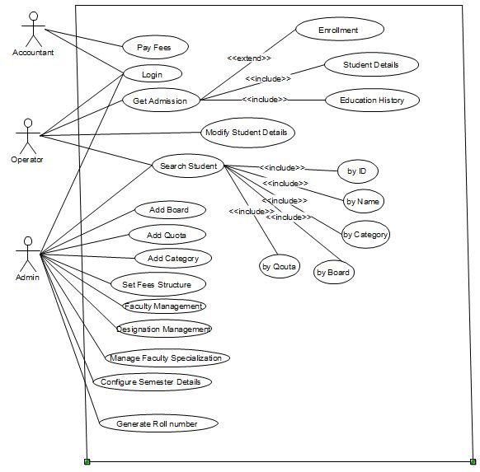
Fig 4.1 Use Case Diagram (Admission Module)

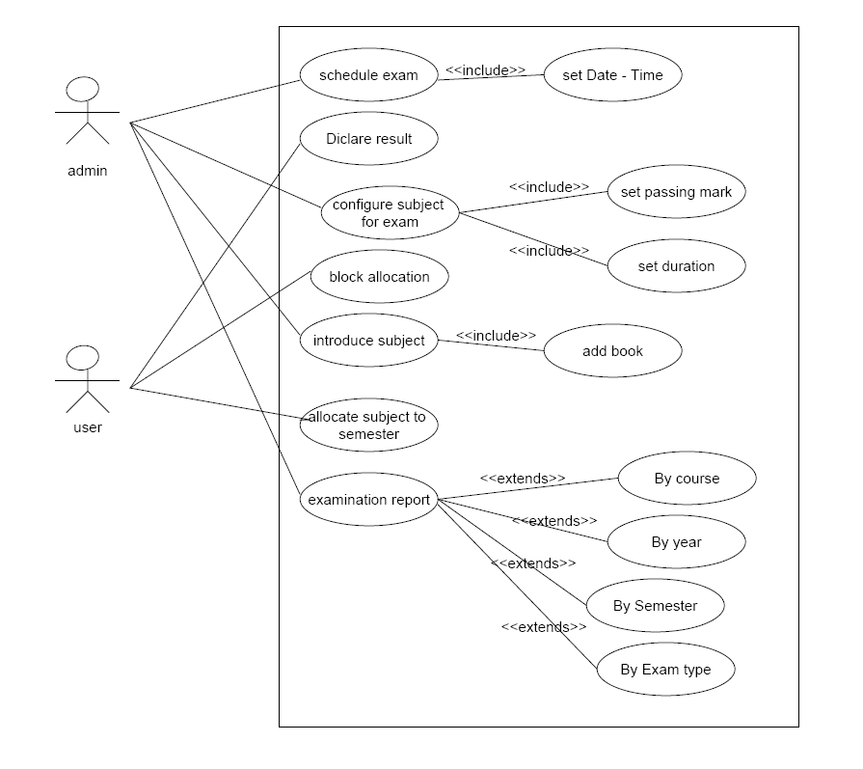
Fig 4.2 Use Case Diagram (Examination Module)

  - DATA MODELING

    - Class Diagram

A class diagram describes the static structure of a system. It shows how a system is structured rather than how it behaves. The static structure of a system consists of a number of class diagrams and their dependencies. The main constituents of a class diagram are classes and their relationships: generalization, aggregation, association, and various kinds of dependencies.
Following diagram represents various classes of the system. The relations between these classes are shown in the next diagram.
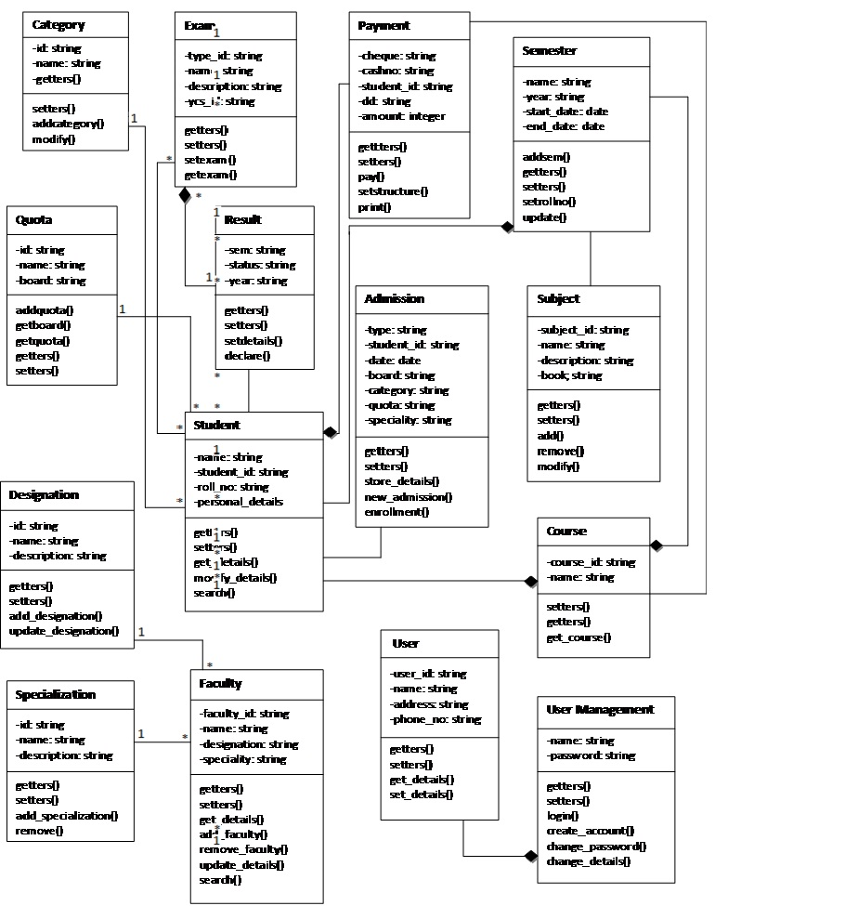

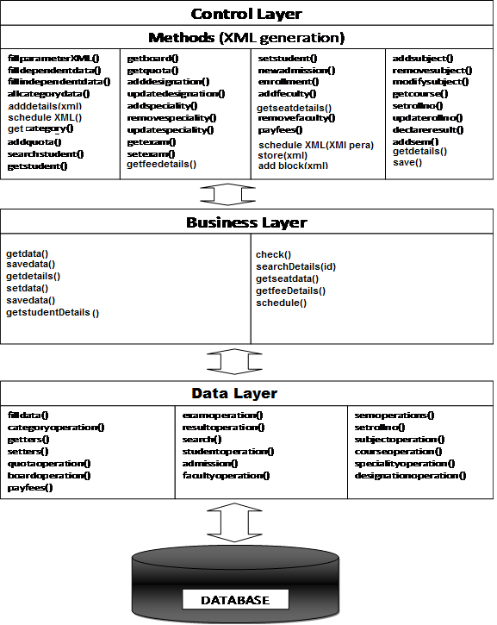

Fig 4.3 Class Diagram of student management system

    - Entity Relationship Diagram

An entity-relationship diagram (ERD) is an abstract and conceptual representation of data. Entity-relationship modeling is a database modeling method, used to produce a type of conceptual schema or semantic data model of a system, often a relational database, and its requirements in a top-down fashion.

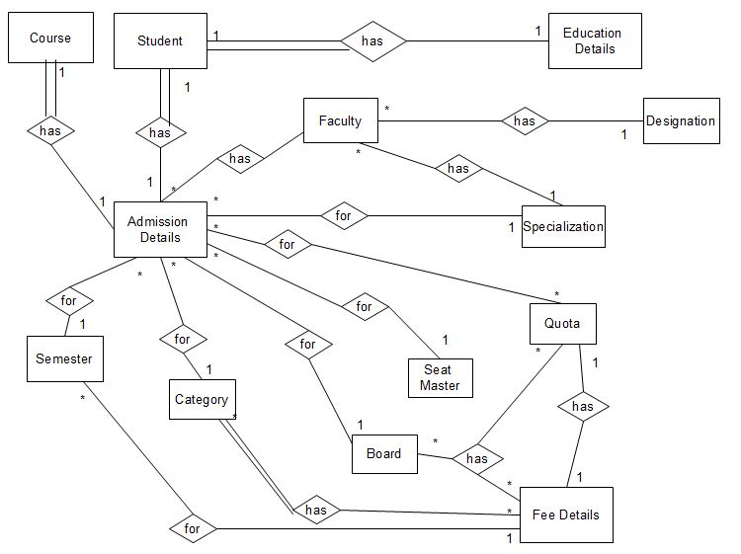

Fig 4.4 ER Diagram for admission

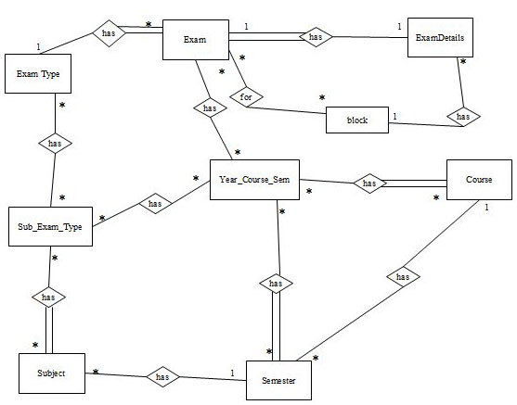

Fig 4.5 ER Diagram for examination

    - Object Interaction Diagram
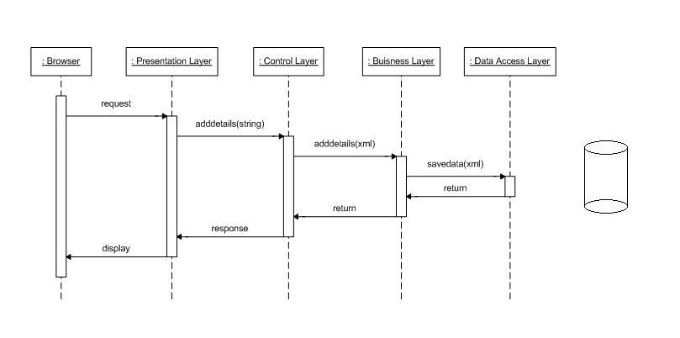

Fig 4.6 Sequence Diagram (Add Board)

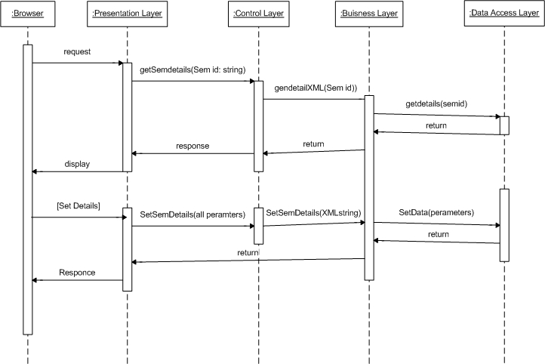

Fig 4.7 Sequence Diagram (Configure Semester )

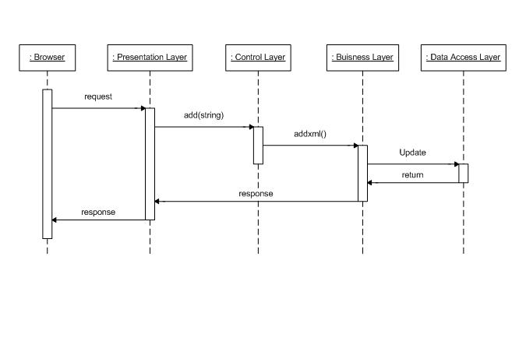
Fig 4.8 Sequence Diagram (Designation)

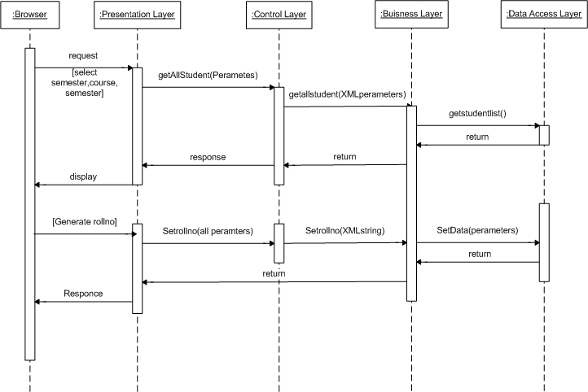
Fig 4.9 Sequence Diagram (Generate Roll No)

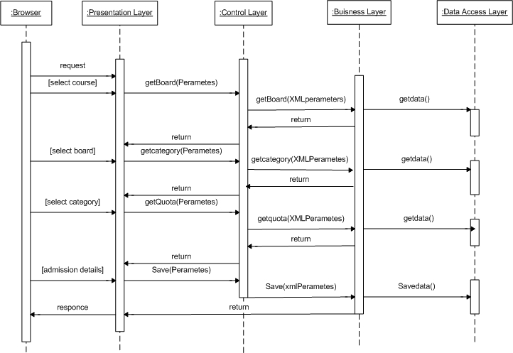

Fig 4.10 Sequence Diagram (Get Admission)

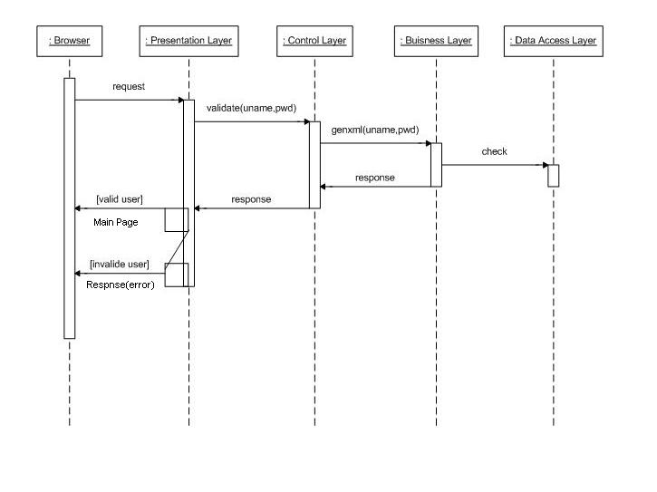
Fig 4.11 Sequence Diagram (Login)

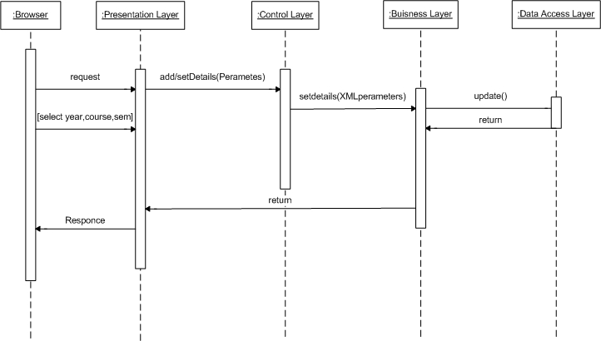

Fig 4.12 Sequence Diagram (Manage Faculty)

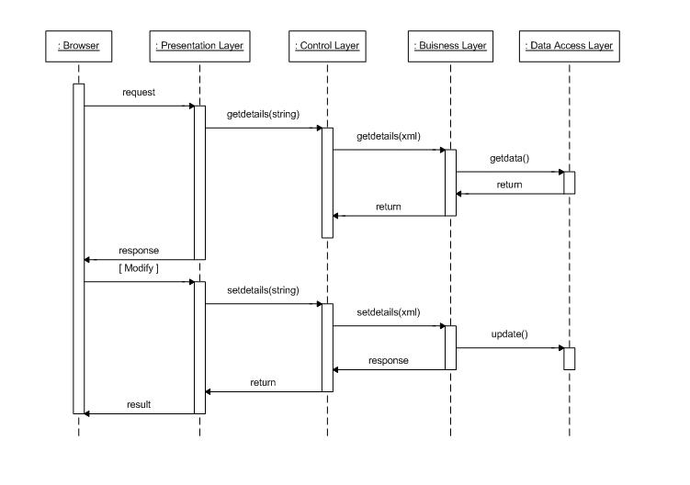
Fig 4.13 Sequence Diagram (Modify Student Details)

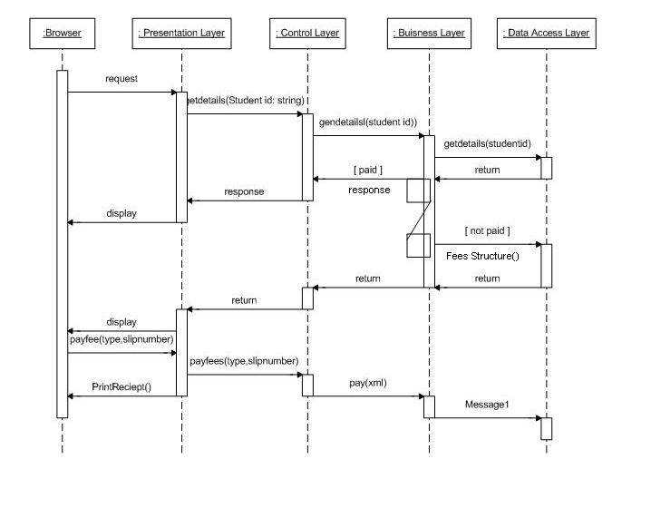

Fig 4.14 Sequence Diagram (Pay Fees)

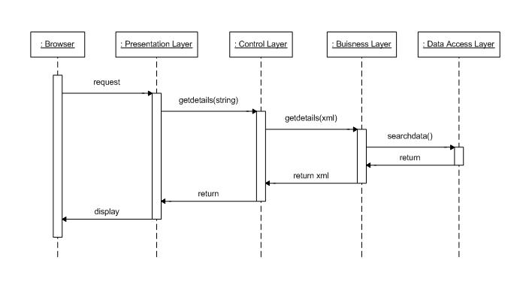

Fig 4.15 Sequence Diagram (Search Students)

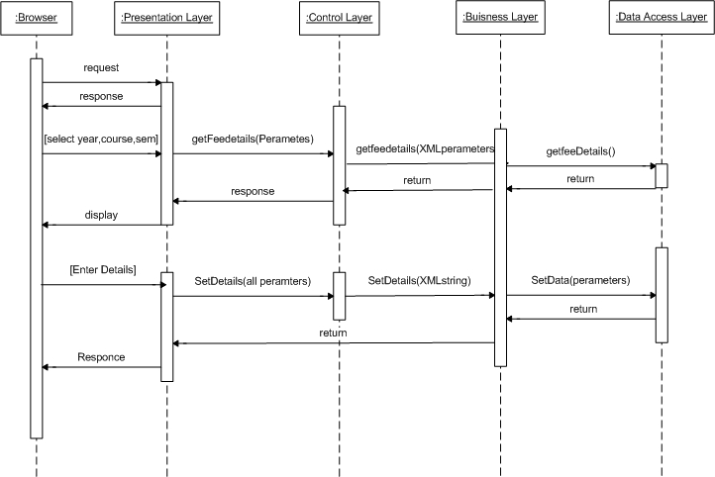

Fig 4.16 Sequence Diagram (Set Fees Structure)

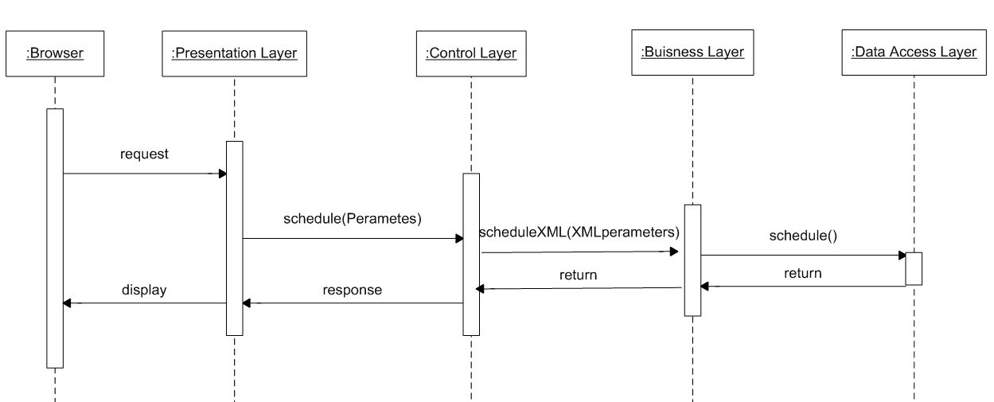

Fig 4.17 Sequence Diagram (Examination Schedule)

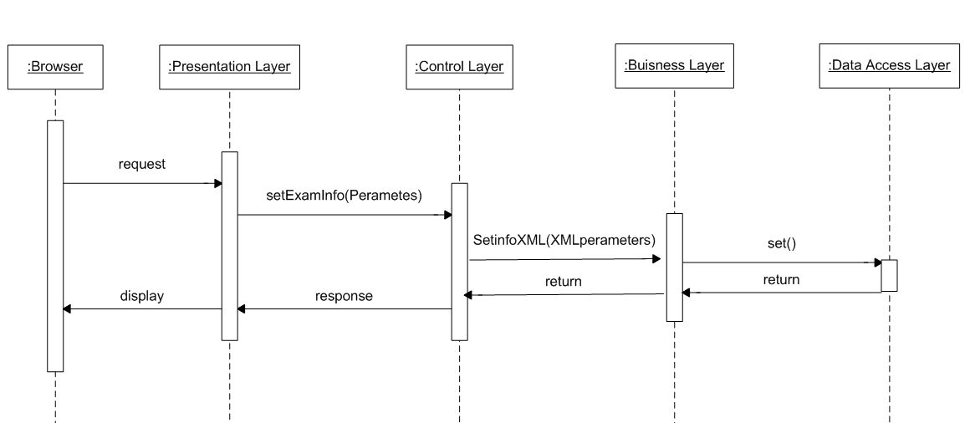

Fig 4.18 Sequence Diagram (Set Exam Information)

    - Data Dictionary

A data dictionary is a catalog --a repository-- of the elements in a system. It includes list of all the elements composing the data flowing through a system. The major elements are data flows, data stores, and processes. It store definitions and detailed descriptions of the data used in an organization’s information system
It is important because –

- To manage the detail in large systems
- To communicate a common meaning for all system elements
- To document the feature of the system
- To facilitate analysis of the details in order to evaluate characteristics and determine where system changes should be made
- To locate error and omissions in the system

List of Data Tables:
            - Board Master
            - Category Master
            - Course Master
            - Exam Details
            - Exam Master
            - Exam Type Master
            - Faculty Designation
            - Faculty Details
            - Fees Details
            - Payment Master
            - Quota Master
            - Result Data
            - Semester Master
            - Specialty Master
            - Student Admission Details
            - Student Education Details
            - Student Personal Details
            - Subject Exam Type Details
            - Subject Master
            - Subject Semester Allocation
            - Year Course Semester

Table 4.1 Table Structure of Board Master

Field | Type | Null | Key | Description
Board_id | Varchar(10) | NO | PRI | primay key
Board_Name | Varchar(50) | NO |  | Board Name(e.g. State,Central)
Description | Varchar(Max) |  |  | Description to the board

Table 4.2 Table Structure of Category Master

Field | Type | Null | Key | Description
Category_id | Varchar(5) | NO | PRI | primary key
Category_Name | Varchar(50) | NO |  | Category name (e.g. SC,OBC)
Description | Varchar(15) |  |  | Description to the category

Table 4.3 Table Structure of Course Master

Field | Type | Null | Key | Description
Course_id | Varchar(5) | NO | PRI | primary key
Course_Name | Varchar(50) | NO |  | Course name
Course_Duration | Numeric(2,0) | NO |  | Duration of course in sem
Description | Varchar(Max)

Table 4.4 Table Structure of Exam Details

Field | Type | Null | Key | Desciption
Exam_id | Varchar(15) | NO | FK | Exam Master
Sub_Exam_id | Numeric(18,0) | NO | FK | Subject Exam Type Detail
Date | DateTime | NO |  | Date of Exam
Exam_Time | DateTime | NO |  | Time of Exam

Table 4.5 Table Structure of Exam Master

Field | Type | Null | Key | Desciption
Exam_id | Varchar(15) | NO | PRI | Primary Key
YCS_id | Varchar(15) | NO | FK | Year Course Sem
Exam_Type_Code | Varchar(15) | NO | FK | Exam Type Master

Table 4.6 Table Structure of Exam Type Master

Field | Type | Null | Key | Description
Exam_Type_Code | Varchar(15) | NO | PRI | Primary key
Exam_Type_Name | Varchar(50) | NO |  | Name of Exam Type
Description | Varchar(Max) |  |  | Description of exam type

Table 4.7 Table Structure of Faculty Designation

Field | Type | Null | Key | Description
Designation_Code | Varchar(10) | NO | PRI | primary key
Designation_Name | Varchar(30) | NO |  | Designation Name
Description | Varchar(Max) |  |  | Description of the designation

Table 4.8 Table Structure of Faculty Details

Field | Type | Null | Key | Description
Faculty_id | Varchar(10) | NO | PRI | primary key
First_Name | Varchar(20) | NO
Middle_Name | Varchar(20)
Last_Name | Varchar(20) | NO
Birth_Date | DateTime
Sex | Varchar(5) | NO | FK
Caste_id | Varchar(5) | NO | FK
subCaste | Varchar(20)
Address1 | Varchar(30) | NO
Address2 | Varchar(30)
City | Varchar(30) | NO
Pincode | Varchar(10) | NO
State | Varchar(20) | NO
Nation | Varchar(20)
Phone_Res | Varchar(15) | NO
Phone_Mob | Varchar(15) | NO
Email_id | Varchar(30) | NO
Alternate_email | Varchar(30)
Designation_Code | Varchar(10) | NO | FK | Designation of Faculty
Specialization_id | Varchar(10) |  | FK | Specialization of Faculty

Table 4.9 Table Structure of Fees Master

Field | Type | Null | Key | Description
Board_id | Varchar(10) | NO | FK | Board Master
Category_id | Varchar(5) | NO | FK | Category Master
Quota_id | Varchar(5) | NO | FK | Quota Master
YCS_id | Varchar(15) | NO | FK
Tution_Fees | Decimal(10,2) | NO
Exam_Fees | Decimal(10,2) | NO
Other_Fees | Decimal(10,2) | NO
Hostel_Fees | Decimal(10,2) | NO

Table 4.10 Table Structure of Payment Details

Field | Type | Null | Key | Description
Student_id | Varchar(15) | NO | FK | Student Details
Sem_id | Varchar(7) | NO | FK
Paid_Date | DateTime | NO |  | Date of Payment
Amount | Decimal(10,2) | NO |  | Total Payment
Paid_By | Varchar(5) | NO | FK | Fees Paid by(e.g. Cash,Cheque)
Slip_Number | Varchar(20) |  |  | Cheque or DD number
Bank_Name | Varchar(50) |  |  | Name of the Bank for Cheque & DD

Table 4.11 Table Structure of Quota Master

Field | Type | Null | Key | Desription
Quota_id | Varchar(15) | NO | PRI | primary key
Quota_Name | Varchar(20) | NO |  | Name of Quota
Description | Varchar(Max)

Table 4.12 Table Structure of Result Data

Field | Type | Null | Key | Description
Exam_id | Varchar(15) | NO | FK | Exam Master
YCS_id | Varchar(15) | NO | FK
Sub_id | Varchar(5) | NO | FK | Subjetc code
Student_id | Varchar(15) | NO | FK | Student details
Marks | Numeric(3,0) | NO |  | Student’s Mark

Table 4.13 Table Structure of Semester Master

Field | Type | Null | Key | Default
YCS_id | Varchar(15) | NO | FK
Start_Date | DateTime | NO |  | Start date of the semester
End_Date | DateTime | NO |  | End date of the semester

Table 4.14 Table Structure of Speciality Master

Field | Type | Null | Key | Description
Speciality_id | Varchar(10) | NO | PRI | Primary key
Speciality_Name | Varchar(50) | NO |  | Specilization Name
Course_id | Varchar(5) | NO | FK | Course Master
Description | Varchar(Max)

Table 4.15 Table Structure of Student Admission Details

Field | Type | Null | Key | Description
Student_id | Varchar(15) | NO | FK | Student Personal Details
YCS_id | Varchar(15) | NO | FK
Date_of_Admission | DateTime | NO
General_Merit_No | Varchar(10) | NO
Category_Merit_No | Varchar(10) | NO
Fresher | Bit | NO
Board_id | Varchar(10) | NO | FK | Board Master
Category_id | Varchar(5) | NO | FK | Category Master
Quota_id | Varchar(15) | NO | FK | Quota Master
Speciality_id | Varchar(10) | NO | FK | Speciality Master
Faculty_id | Varchar(10) | NO | FK | Faculty Master
Hostel | Bit | NO
Remarks | Varchar(MAX)

Table 4.16 Table Structure of Student Education Details

Field | Type | Null | Key | Description
ID | Numeric(18,0) | NO | PRI | primary key
Student_id | Varchar(15) | NO | FK | Student Personal Details
Descipline | Varchar(30) | NO
Board | Varchar(30) | NO
Institute | Varchar(30) | NO
Percentage | Numeric(4,2) | NO
Year_of_Completion | Numeric(4,0) | NO
Achievments | Varchar(MAX)

Table 4.17 Table Structure of Student Personal Details

Field | Type | Null | Key | Description
Student_id | Varchar(15) | NO | PRI | Primary key
First_Name | Varchar(20) | NO
Middle_Name | Varchar(20)
Last_Name | Varchar(20) | NO
Birth_Date | DateTime
Sex | Varchar(5) | NO | FK
Father_Income | Decimal(10,2) | NO
Caste_id | Varchar(5) | NO | FK
subCaste | Varchar(20)
Address1 | Varchar(30) | NO
Address2 | Varchar(30)
City | Varchar(30) | NO
Pincode | Varchar(10) | NO
State | Varchar(20) | NO
Nation | Varchar(20)
Phone_Res | Varchar(15) | NO
Phone_Mob | Varchar(15) | NO
Email_id | Varchar(30) | NO
Alternate_email | Varchar(30)
Status | Bit

Table 4.18 Table Structure of Subject Exam Type Details

Field | Type | Null | Key | Description
Sub_Exam_id | Numeric(18,0) | NO | PRI | Primary key
Sub_Code | Varchar(5) | NO | FK | Subject Master
Exam_Type_id | Varchar(5) | NO | FK | Exam Type Master
Speciality_id | Varchar(10) |  | FK | Speciality Master
YCS_id | Varchar(15) | NO | FK
Duration | Real | NO
Total_Marks | Numeric(3,0) | NO
Passing_Marks | Numeric(3,0) | NO

Table 4.19 Table Structure of Subject Master

Field | Type | Null | Key | Description
Sub_Code | Varchar(5) | NO | PRI | Primary key
Sub_Name | Varchar(30) | NO |  | Name of the Subject
Text_Book | Varchra(30) |  |  | Name of the Book
Reference_Book | Varchar(100) |  |  | Name of the Books
Description | Varchar(MAX)

Table 4.20 Table Structure of Subject Semester Allocation

Field | Type | Null | Key | Description
ID | Varchar(18,0) | NO | PRI | Village id
YCS_id | Varchar(15) | NO | FK
Speciality_id | Varchar(10) |  | FK | Speciality Master
Sub_Code | Varchar(5) | NO | FK | Subject Master

Table 4.21 Table Structure of Year Course Semester

Field | Type | Null | Key | Descrrption
YCS_id | Varchar(15) | NO | PRI | primary key
Year | Varchar(4) | NO
Course_id | Varchar(5) | NO | FK | Course Master
Sem_id | Varchar(7) | NO | FK
  - FUNCTIONAL AND BEHAVIORAL MODELING

    - Context Diagram
The context diagram is the most abstract data flow representation of a system. It represents the entire system as a single bubble and. The various external entities with which the system interacts and the data flows occurring between the system and the external entities are also represented. The name context diagram is well justified because it represents the context in which the system is to exist i.e. the external entities (users) that would interact with the system and specific data items they would be receiving from the system.
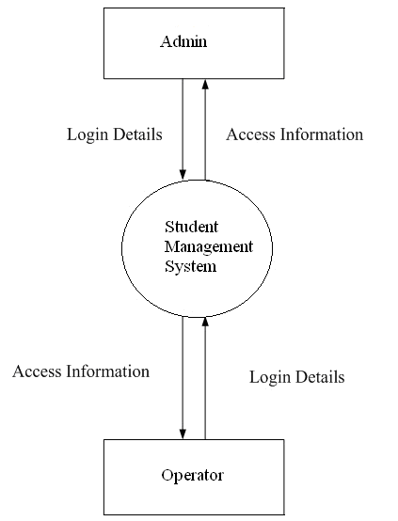
Fig 4.19 Context diagram of Student Management System

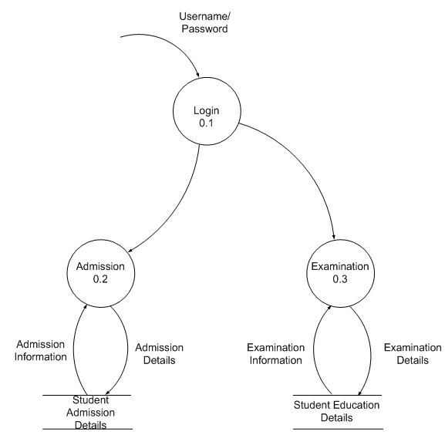
Fig 4.20 Level-1 Data flow diagram of Student Management System
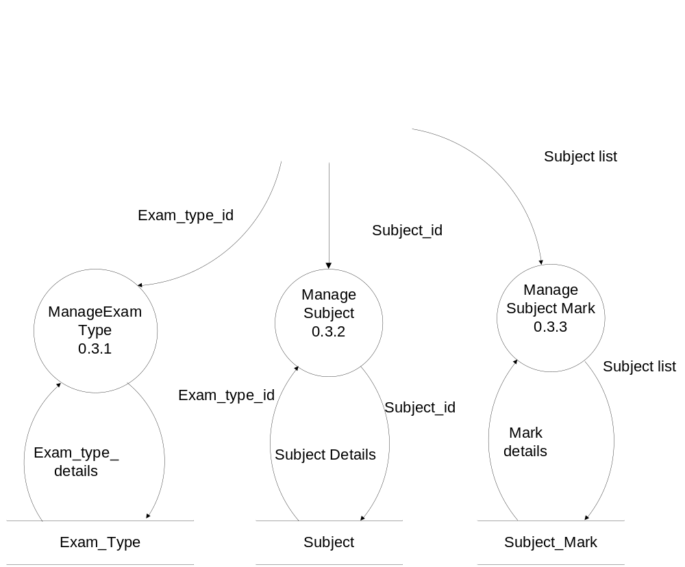
Fig 4.21 Level-2 Data flow diagram of examination

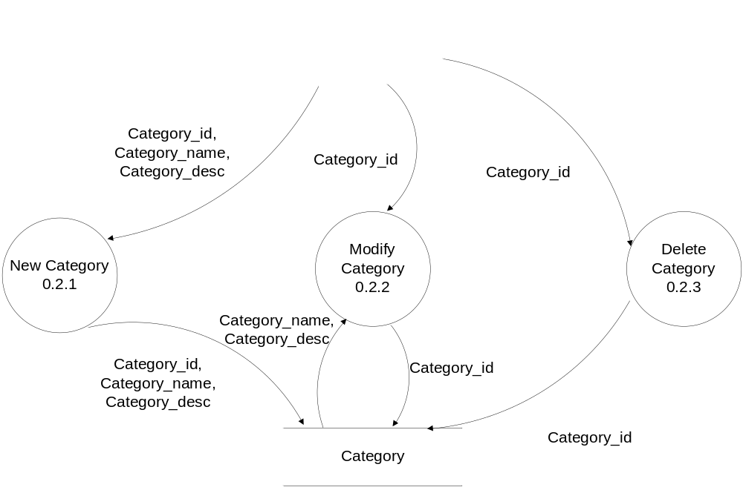
Fig 4.22 Level-2 Data flow diagram of category

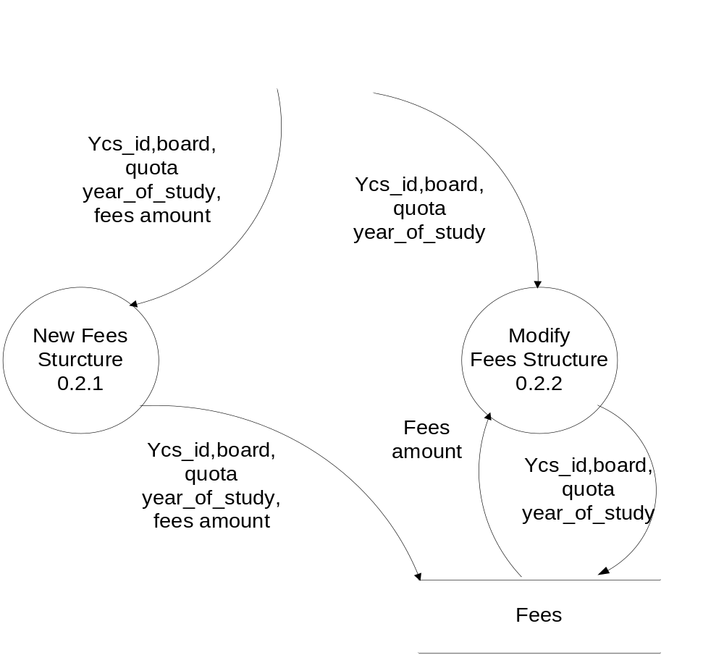
Fig 4.23 Level-2 Data flow diagram of fees structure

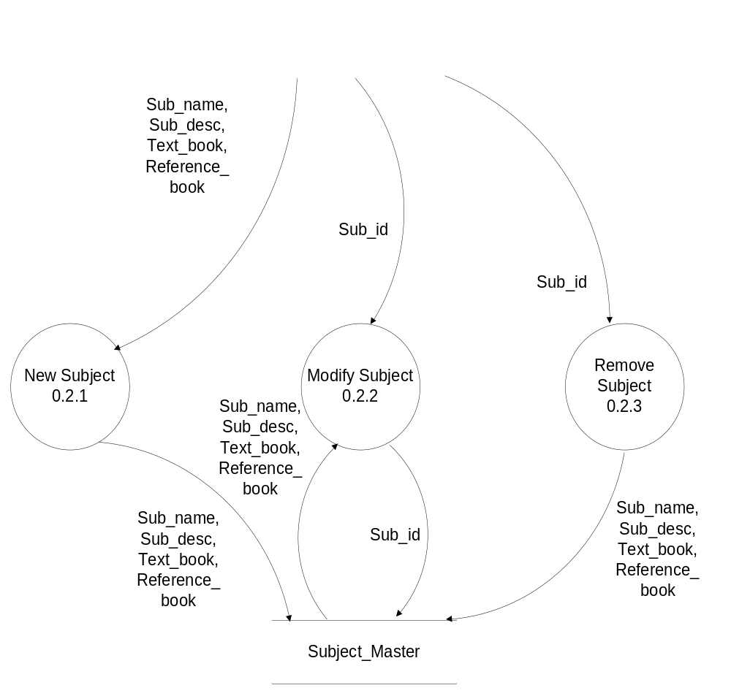
Fig 4.24 Level-2 data flow diagram of subject

  - MAIN MODULES OF NEW SYSTEM

- Admission Module
  - Student Registration
  - Semester Screen
  - Category Screen
  - Payment Screen
  - Faculty Screen
  - Seat Master
  - Student Fees Screen
  - Roll No. Generation Screen
  - Student Report Generation Screen

- Examination Module
  - Exam Type Screen
  - Examination Scheduling Screen
  - Subject Master Screen
  - Subject Examination Marks Allocation Screen
  - Subject Allocation Master
  - Result Entry Screen
  - Examination Scheduling Report

  - SELECTION OF HARDWARE AND SOFTWARE JUSTIFICATION

The development of the system “STUDENT MANAGEMENT SYSTEM” is composed of the following components:
- Java Script.
- ASP.NET
- XML (Extensible Markup Language).
- SQL Server 2005.
- PHOTSHOP
- AJAX
- AAA LOGO

- JavaScript:

- JavaScript is the programming language of the web.
- Java Scripts can be inserted into HTML documents, to make the web pages more dynamic and interactive
- JavaScript is a scripting language.
- JavaScript is supported by Major web browsers.
- When a JavaScript is inserted into an HTML document, the Internet browser will read the HTML and interpret the JavaScript.
- JavaScript gives HTML designers a programming tool
- JavaScript is a very light programming language with very simple syntax.
- JavaScript can put dynamic text into an HTML page

- ASP .NET:
- ASP.NET is Microsoft's new Internet and Web strategy
- ASP.NET is NOT a new operating system
- ASP.NET is a new Internet and Web based infrastructure
- ASP.NET delivers software as Web Services
- ASP.NET is a framework for universal services
- ASP.NET is a server centric computing model
- ASP.NET will run in any browser on any platform
- ASP.NET is based on the newest Web standards

.NET Framework 3.5
The .NET Framework is Microsoft's comprehensive and consistent programming model for building applications that have visually stunning user experiences, seamless and secure communication, and the ability to model a range of business processes.
The .NET Framework 3.5 introduces new features for the technologies in 2.0 and 3.0 and additional technologies in the form of new assemblies. The following technologies are introduced with the .NET Framework 3.5:
- Language Integrated Query (LINQ).
- New compilers for C#, Visual Basic, and C++.
- ASP.NET AJAX.
- Hyper Text Mark-Up Language (HTML)
- HTML = HyperText Mark-up Language
- Universal, non-proprietary, structured, text mark-up language
- Used to publish documents on the World Wide Web
- Used to define the structure of documents and links between documents
- An application of Standard Generalized Mark-up Language.
- Style sheets
- Scripting
- Internationalization
- Accessibility
- Extensible Markup Language (XML)
- XML stands for Extensible Markup Language
- XML is a markup language much like HTML.
- XML was designed to describe data.
- XML tags are not predefined in XML. You must define your own tags.
- XML uses a DTD (Document Type Definition) to describe the data.
- XML with a DTD is designed to be self-describing.

